**OUSR URL** - https://www.clicksafety.com/overaa

**Buttons** – see jpgs in folder

**Colors**

Cell Color 1: #485E87

Cell Color 2: #485E87

Cell Color 3: #999999

**Body**

**Overaa Construction**

SAFETY TRAINING

Welcome to the Overaa Construction Safety Training Portal. To further our efforts toward providing the safest possible construction sites, Overaa has teamed up with ClickSafety to provide on-line training for Safety as well as for other programs.

Register Now

(hoover should be #485E87 with white text)

(add image from folder, overaa_bill.jpg)

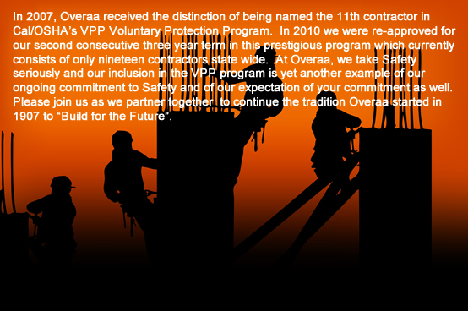

**SUPPORT**

**Overaa Employee Contact**

Lisa Cooper

510.234.0926

lisac@overaa.com

SUPPORT

Powered By

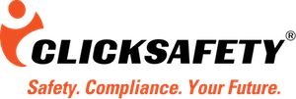 (hyperlink image to <https://www.clicksafety.com/>)

HelpDesk & FAQ (hyperlink text to <https://support.clicksafety.com/hc/en-us>)

800-971-1080

support@clicksafety.com